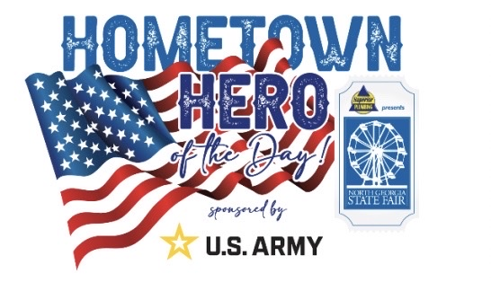

The Superior Plumbing presents North Georgia State Fair, and the U.S. Army are proud to support our active-duty Army, veterans, and their families. The Fair wants to honor the men and women who keep this country safe by recognizing them as a Hometown Hero. Throughout the Fair, individuals that are enlisted in the U.S. Army or are U.S. Army veterans will be honored. This recognition program is designed to showcase those U.S. Army individuals who have made a significant impact through their military service. Nominees can nominate themselves or be nominated by a friend or family member. Tell us what makes your nominee a Hometown Hero. A submission does not guarantee selection. Hometown Heroes are selected by a committee. The nominee must be 18 years of age or older and currently enlisted in the U.S. Army or is a veteran of the U.S. Army. If your candidate is selected, you will be notified by a member of our committee. By applying you accept all the terms and conditions herein and have obtained permission to use information and photographs of the nominee.

If you are selected you will receive Fair Admission for up to 6 people, unlimited rides for up to 6 people, free parking, and $100.00 cash spending money.

