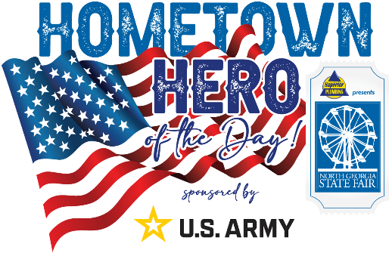

HOMETOWN HERO AWARD APPLICATION
Nominator Information
Full Name:____________________________________________________________________________
Email Address:_________________________________________________________________________
Phone Number:________________________________________________________________________
Relationship to Nominee:________________________________________________________________
Nominee’s Information
Full Name:____________________________________________________________________________
Email Address:_________________________________________________________________________
Phone Number:________________________________________________________________________
Army Occupation:____________________________________________________________________
Highest Achieved Rank:________________________ Current Status:_____________________________
Please list any medals or honors this Nominee has received: ____________________________________
_____________________________________________________________________________________
_____________________________________________________________________________________
_____________________________________________________________________________________
_____________________________________________________________________________________
Why does the person deserve to be honored as a Hometown Hero? (500 words or less) ______________
_____________________________________________________________________________________
_____________________________________________________________________________________
_____________________________________________________________________________________
_____________________________________________________________________________________
_____________________________________________________________________________________
_____________________________________________________________________________________
_____________________________________________________________________________________
_____________________________________________________________________________________
Please tell us a heroic event, or a story of valor, about this Nominee? (500 words or less) _____________
_____________________________________________________________________________________
_____________________________________________________________________________________
_____________________________________________________________________________________
_____________________________________________________________________________________
_____________________________________________________________________________________
_____________________________________________________________________________________
_____________________________________________________________________________________
_____________________________________________________________________________________
_____________________________________________________________________________________

List any other important details about this Nominee’s service that may be helpful for us to consider? (500 words or less)
_____________________________________________________________________________________
_____________________________________________________________________________________
_____________________________________________________________________________________
_____________________________________________________________________________________
_____________________________________________________________________________________
_____________________________________________________________________________________
_____________________________________________________________________________________
_____________________________________________________________________________________
_____________________________________________________________________________________

List what day you can be recognized and honored at the North Georgia State Fair between September 21-October 1, 2023: ____________________________________________________________________

PLEASE EMAIL THIS APPLICATION AND A PICTURE OF THE NOMINEE TO laura@jrmmanagement.com
NO LATER THAN SEPTEMBER 15, 2023
ALL APPLICANTS MUST BE CURRENTLY ENLISTED IN THE UNITED STATES ARMY OR A VETERAN HAVING SERVED IN THE UNITED STATES ARMY.

