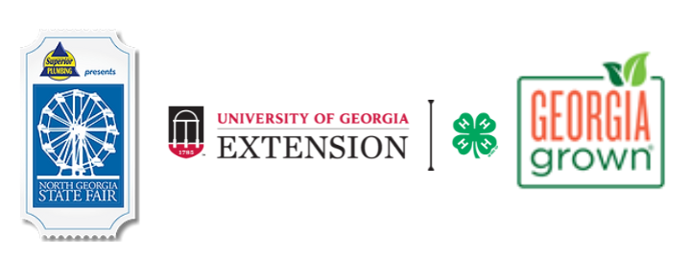
Enter the 4-H Hay Bale Decorating Contest!
1st Place - $1,000, 2nd Place - $500, 3rd Place - $250! Many thanks to Georgia Grown for sponsoring this year’s prizes! All groups that participate will receive 15 admission passes to the fair!
- Who Can Participate?
Contest is open to K-12 youth and school clubs/organizations (examples: 4-H Horse and Pony Club, Girls Inc., Boy Scouts, softball team, high school band, middle school recycling club, elementary school reading club). Youth participation is what this is about! See past winners at the North Georgia State Fair Facebook page.

- Registration Information:
There is no fee to register for this contest. The registration form and sketch of hay bale design must be emailed to Kelsey.Andries@cobbcounty.gov by Tuesday, September 1st, 2026. No late submissions will be accepted. Limited spots are available. A confirmation of registration will be emailed to you.

- Hay Bale and Decoration Information:
The 2026 hay bale decorating theme is “Fair Nights Under Stars & Stripes”!
  - Decorating time is open Saturday, September 19 (2-6pm); Sunday, September 20 (1-4:30pm); Tuesday, September 22 (2-6pm); Wednesday, September 23 (6-8:30pm) Judging will take place the morning of Thursday, September 24.
  - Entries will be judged on representation of the theme, youth participation, creativity, use of materials, construction, and eye appeal.
  - We love to see youth participation! Optional - Email no more than two pictures Kelsey.Andries@cobbcounty.gov of your youth group working on the hay bale. This is great exposure for your organization and a fun way to share the hay bale decorating contest! It is your organization’s responsibility to obtain permission for the photo to be shared with the public on social media and other communication and marketing networks.
  - One round hay bale per group is provided by the North Georgia State Fair. The hay bale will be positioned on its side. Groups may bring up to 4 additional small rectangular bales. This should be indicated on the sketch. Do not stack other hay bales on the large round one. Think safety!
  - Upon arrival, one adult group member should go to the Fair Office at Jim R. Miller Park Event Center. Fair Staff will assist with the location of the hay bales. A maximum of 8 people from each group are allowed to decorate at one time.
  - Hay bales must be decorated so that they are family appropriate and abide by the Georgia 4-H Code of Conduct: http://secure.georgia4h.org/documents/CodeOfConduct.pdf. Do not promote religious, commercial, or political themes.
  - Here's a cleaner, more professional version of your bullet point:
  - Items attached to the bale must be able to withstand up to two weeks of outdoor exposure and be weather- and wind-resistant. Paper materials should be laminated prior to installation. Tape alone is not sufficient to secure items; the use of landscape staples is highly recommended. Any items that become detached during the display period may be discarded.
  - Decorations can extend up to 2 feet on each side and 3 feet in front. Paint should only be applied to the hay bale and not the surrounding ground.
  - The North Georgia State Fair & the University of Georgia Extension - Cobb County will not be held responsible for any personal items removed or damaged.
  - Decorations must remain on the hay bale during the fair. Decorations must be picked up on Mon., October 5, 9am-12pm and 5pm-8pm. Items not picked up will be discarded. NO EXCEPTIONS.
  - Groups that register to participate are responsible for decorating their assigned hay bale. Failure to decorate the bale by the designated deadline will result in the hay bale being displayed as-is, with the registered group's name identified on the display.
  - It is the group’s responsibility to notify their organization’s administration about their participation in this event. Winners will be given a check in the name of the organization that you are representing. All permissions, insurance, medical forms, sign-in sheets, code of conduct forms, and other administrative requirements as required by your respective organizations for this event are the responsibility of the registering group. For example, 4-H Clubs should notify their Extension Agent or club liaison a week in advance to procure insurance for the event.

Contact information:
UGA Extension – Cobb County 4-H
Kelsey Andries
Kelsey.Andries@cobbcounty.gov
770-528-4070
678 South Cobb Drive, Suite 200, Marietta, GA
Registration Form for Hay Bale Decorating Contest
The registration form and a sketch of the hay bale is due to Kelsey Andries at Kelsey.Andries@cobbcounty.gov by Tuesday, September 1, 2026.

School, club, organization name. Contest is open to K-12 youth and school clubs/organizations:
__________________________________________________________________________________________

Adult leader responsible for the youth group:
__________________________________________________________________________________________

Adult leader’s email address:
__________________________________________________________________________________________

Adult leader’s phone number:
__________________________________________________________________________________________

Organization’s mailing address:
__________________________________________________________________________________________

