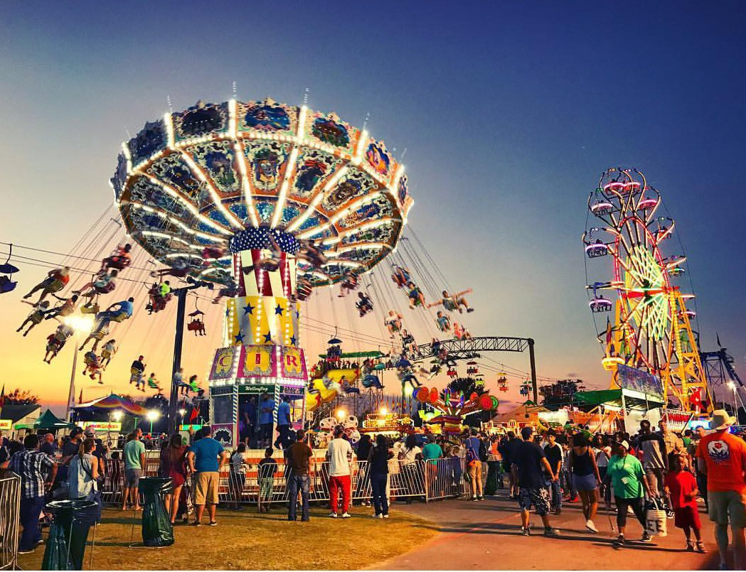
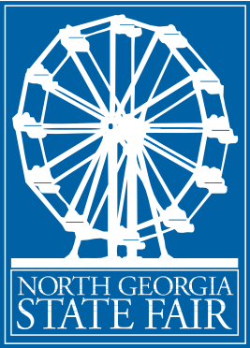
SUPERIOR PLUMBING presents pres
NORTH GEORGIA STATE FAIR
90TH ANNUAL

SEPTEMBER 22-
MARIETTA, GA
OCTOBER 2, 2022
JIM R MILLER PARK

2022 SPONSORSHIP OPPORTUNITIES

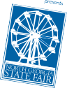
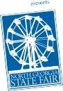
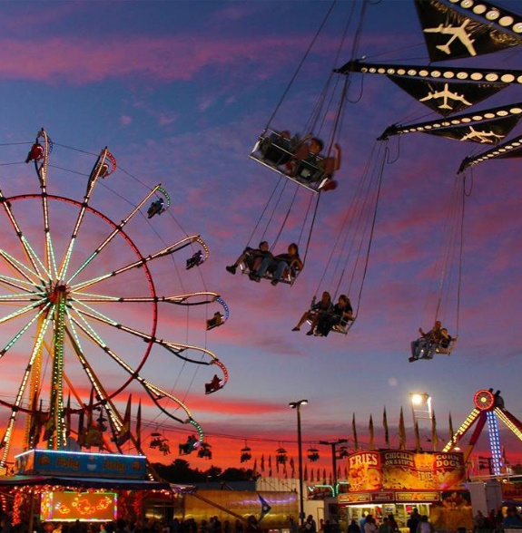

JOIN US IN 2022
The Fair offers many corporate marketing opportunities that recognize the value of partnership with one of Georgia’s largest and longest running outdoor events. The Superior Plumbing presents North Georgia State Fair is a true celebration of community and cultural heritage.

Bill Watson Sponsorship Director North Georgia State Fair
bill.watson@northgeorgiastatefair.com 770.423.1330
For more information contact: Bill Watson 770.423.1330
02

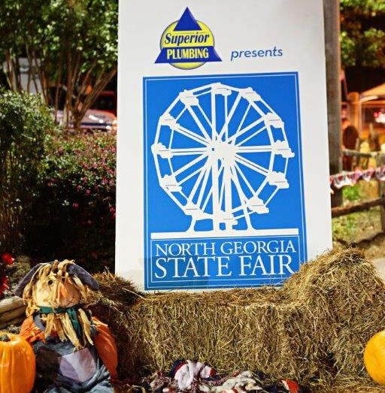
The Superior Plumbing presents North Georgia State Fair has established itself as one of the south’s largest and longest running outdoor events. Annually attracting more than three hundred thousand people from the Southeast, our Fair, held in Marietta, is one of Georgia’s leading fairs!

If you are looking for on-site exhibit space to engage with Fairgoers or on- site branding and logo placement we can accommodate your needs and assist you in meeting your goals.

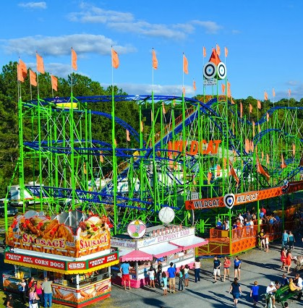
Based upon past promotional experiences, the Superior Plumbing presents North Georgia State Fair can provide sponsors with a specific expected audience composition. For instance, the pay-one-price promotions will draw a large teen audience, where as a Saturday morning promotion will draw families with young children. As with any state fair, there are many simultaneous events, attractions and venues from which visitors may choose at any given time or day. Often the Fair will develop a specific event or attraction, depending upon a corporate sponsor’s needs.

The 90th Annual Superior Plumbing presents North Georgia State Fair is expected to draw over three hundred thousand Fairgoers. An outstanding concert line-up and numerous activities for all family members tend to be the top draws. Overall, the demographics of the Fair are families with children, between $75,000 -
$85,000+ combined head-of-household incomes, ranging in age from 19 - 45 with an average age of 36.

A record-breaking attendance six of the last seven years is a testament to its success. Capacity crowds have produced tremendous returns for past and repeat Superior Plumbing presents North Georgia State Fair sponsors. The Fair works with each of its sponsors to develop and implement the right marketing strategies for the wide cross-section of target segments that exist during the event. Corporate objectives are matched with the appropriate event, attraction, concert, and day or evening midway promotions in order to maximize sponsorship dollars.

- A metro-wide and regional Fairgoer demographic reach

- Access to over 300,000+ Fairgoers

- An extensive $500,000 pre-event media outreach program and metro-wide editorial coverage
Build your
brand
- James H. Drew Exposition –
one of the safest carnival midways

- Opportunity to increase

brand awareness

- Opportunity to brand a wide variety of fair assets

- Opportunity to sample or coupon products to target consumers

- Opportunity to

gather consumer leads

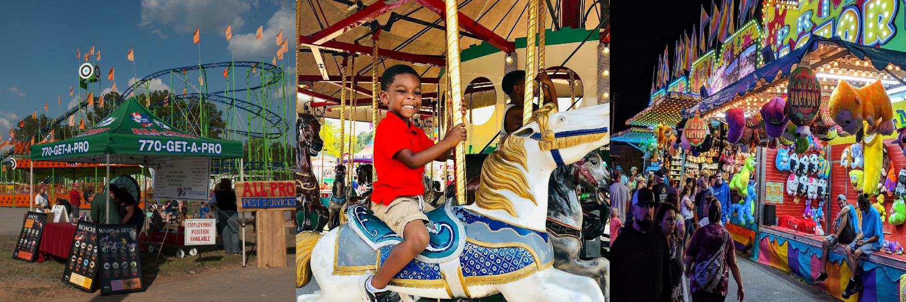
- Customized packages and benefits to accomplish your marketing goals and objectives, all within your budget

48%
<<MALE
FEMALE>>
65%
<<of Fairgoers are between the ages of 19 and 45
More than 50% of Fairgoers return each year
50%
52%
DAILY ATTENDANCE
13%
5%
6%
14%
18%
Average annual household income ranges
$75K $85K
11%
8%
56% Caucasian, 29% African-American 15% other race ethnicity
6%
6%
8%
5%
For more information contact: Bill Watson 770.423.1330
Thursday
Friday Saturday Sunday Monday Tuesday Wednesday Thursday Friday Saturday Sunday
03

FAIR FACTS:

fun

FAIRGOERS DEMOGRAPHICS 2021 NORTH GEORGIA STATE FAIR
midway full of
interaction
Great family

NORTH GEORGIA ANIMALS PETTING BARN
Horses, cows, llamas, goats and other Barnyard Animals are located in the barn at the south entrance of the fairgrounds. For many of the children attending, this is the first opportunity to see these animals up close and personal and pet them.
CONCERT
SERIES

BEAUTIFUL BABY CONTEST
Who doesn’t love babies??? There is always a great response to the Beautiful Baby Contest under the large arena. On Tuesday night, babies in divisions (0-6 months, 6-12 months, 12-24 months, 2 years and 3 years) compete for ribbons and trophies. Along with the families of the contestants, the annual contest always draws a large crowd.
FREE WITH
ADMISSION

BEAUTY PAGEANTS
The annual Fairest of the Fair Beauty Pageants are held on Opening Night of the Superior Plumbing presents North Georgia State Fair. There are five divisions of the pageants, beginning at age 4. The Mini Miss competition is for 4,5 and 6 year- olds. The Little Miss pageant is for 7,8 and 9 year-olds. The Little Junior Miss is for 10, 11 and 12 year-olds. Junior Miss is for 13, 14 and 15 year-olds and the Senior Miss competition is for 16-25 year-olds. Three finalists are selected for each division except Senior Miss, five finalists are chosen for this division. The queen of each division will receive a trophy, flowers, a tiara and savings bond.

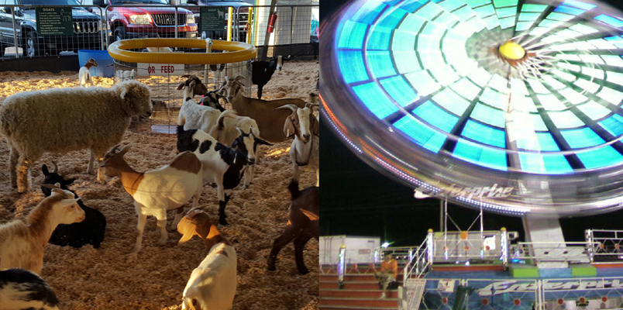

CONCERT SERIES

OWN A PIECE OF THE FAIR!
Top name entertainers perform shows nightly at the Superior Plumbing presents North Georgia State Fair. The concerts are FREE with paid admission to the Fair and are held in the covered grandstand arena.
SOLD

DIRECTIONAL MAPS
Lost??? There are Directional Maps stationed throughout the fairgrounds. These maps include all attractions and events at the Fair. They also include a schedule of times for shows, concerts and contests.

FAMILY FUN DAY
The last Saturday of the Fair is always Family Fun Day. Between 10am-11am gate admission and carnival rides are FREE!!! From 11am-3pm it is Pay-ONE-Price for unlimited carnival rides (good until close).

OWN A PIECE OF THE FAIR!

FIREWORKS
Each weekend night of the Fair is not complete without a spectacular Fireworks Show! The fireworks light up the sky at the conclusion of the concerts by the entertainment held in the grandstands.

FIRST AID
With more than 365,000 in attendance over 11 days, someone is bound to fall and scratch a knee. The First Aid station, located near the main entrance, is there to take care of those cuts and scrapes. Teams of EMTs are on hand during fair hours in case of emergencies.

FLOWER SHOWS
Two sanctioned Flower Shows are held annually at the Fair. The first begins Thursday, September 22nd – Tuesday, September 27th. The second begins Wednesday, September 28th – Sunday, October 2nd. Nationally accredited judges judge the Flower Show. Winners receive ribbons and Top Honors are awarded pieces of crystal.

GOLF CARTS
The Superior Plumbing presents North Georgia State Fair management team use Golf Carts to cover the grounds quickly. A minimum of eight Golf Carts are in constant use during operating hours. The carts are not restricted from any part of the grounds and are seen by everyone and you can brand them with your company for all to see.

INFORMATION BOOTH
The Information Booth is centrally located at the event center. Visitors can get information regarding fair events and hours, show and contest times or just directions to specific attractions.
SOLD

LOCAL STAGE
Centrally located on the fairgrounds in the O’Reilly Pit Stop Food Court has a full schedule of local entertainment. Local groups perform nightly during the week and daily and nightly during weekends. You can name this everchanging stage while parents, grandparents and friends and family come to cheer on their local stars.

LOST AND FOUND PARENTS
Lost and Found Parents is located inside the main gate entrances. A tent is staffed with Fair representatives equipped with radio communications to the Fair office at all times. Lost children and parents can come to the tent and wait for their party to find them. Drinks and light snacks are provided to help calm children and/or parents.

MAIN STAGE
Features a variety of live music (Country/ Christian/Rock) and where the Beautiful Baby Contest and Beauty Pageants take place throughout the 11 days of the Fair. Your company has the opportunity to present the music and/or brand the stage for the 11 days of the Superior Plumbing presents North Georgia State Fair.

O’REILLY AUTO PARTS PIT STOP FOOD COURT
The Food Court occupies our O’Reilly Pit Stop Food Court which is centrally located on the fairgrounds. Additionally, the Food Court is also where our Local Stage is located.

SENIOR CITIZENS DAY
Friday, September 23rd will be the Superior Plumbing presents North Georgia State Fairs Annual Senior Citizens Day. The fairgrounds will open at 10am for all seniors. Activities for the day will include health screenings, special concerts and games for the seniors to play.

SPECIAL POPULATIONS DAY
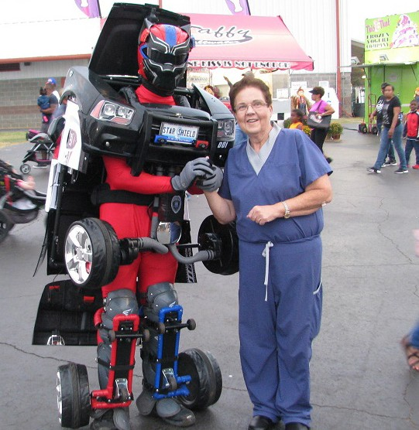
The Fair reserves a special day for the mentally and physically handicapped. Tuesday, September 27th is Special Populations Day with free admission, dinner and free ride tickets.

BRIAN RUTH
“MASTER OF THE CHAINSAW”
Brain Ruth will transform a raw, two- foot log into a true work of art with only a chainsaw. Ruth has been carving sculptures for more than 20 years. The Chainsaw Carvings will be auctioned on the Local Stage, Saturday, October 1st at 7pm.
BRIAN

EUDORA FARMS EXOTIC PETTING ZOO
Experience an interactive, hands-on exotic animal petting zoo. This year we will have twenty to twenty-five rare and exotic animals from around the world.
See a wallaby, zebra, lemur and even a once in a lifetime chance to ride a
camel. This is an experience the whole family won’t soon forget.

ARCY: PAINT EXTRODINARE
ARCY has created hundreds of live murals and permanent large scale works throughout North America, Australia and Europe. ARCY has worked for the likes of the Smithsonian Institute, Major League Baseball, America’s National Parks Service, and is currently developing a collaborative body of work for The Walt Disney Company as a fine artist.
ARCY

RUTH

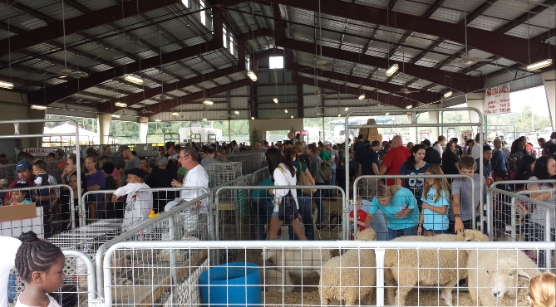

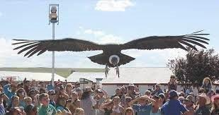

ROBOCARS

NAME ONE OF OUR GROUND ACTS
For more information contact: Bill Watson 770.423.1330
07
Robocars are life size transforming robot vehicles. Available for photos daily around the ground.

THE BIRDMAN

“WORLD CLASS BIRD SHOW”
This NEW show is an action packed, educational, family-oriented show, featuring a variety of birds. This informative presentation is the nation’s largest traveling bird show.

ONE WHEEL WONDER
NEW this year is Wesley Williams. He is keeping audiences on the edge of their seat with his thrilling and charismatic presentation!

ROSAIRE’S ROYAL RACERS
This NEW racing pigs show is for the entire family. Kids and adults will “squeal” with delights as these speedy swine fly around the track.

Wesley Williams
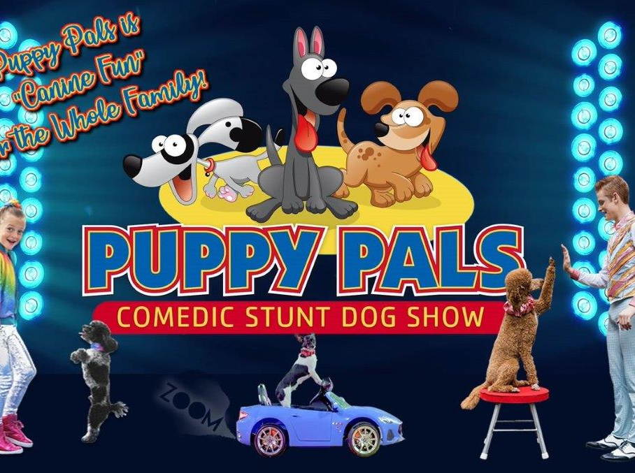

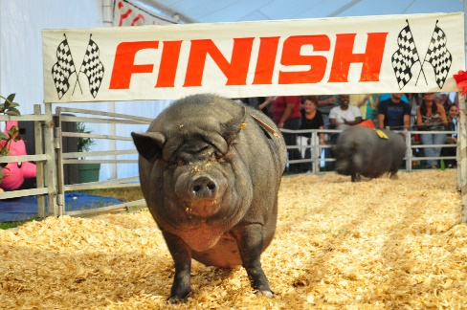

“MAGIC MAN” TJ HILL
Magic Man TJ Hill has traveled the country with his unique style of comedy and magic for over a decade. His show is filled with music, audience participation, hilarious comedy, and unbelievable magic! Watch as someone defies gravity by floating in mid-air and borrowed objects appear in the most impossible places!
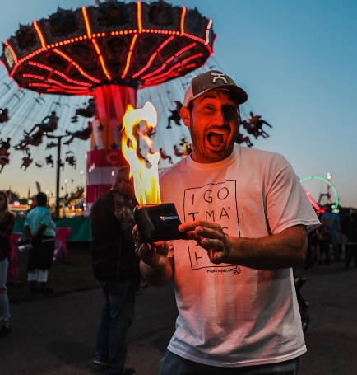
Treeman

PUPPY PALS
This NEW comedic stunt dog show is an action-packed family fun show where adopted and rescued dogs perform spectacular stunts and breathtaking feats.

WALKING TREEMAN & COWBOY WOODY
Don’t miss the Walking Tree Man! Barely distinguishable from real trees, Walking Tree Man moves slowly and deliberately down the street at over 12 feet tall. Tree Man can be seen from 150 yards away! Keep your eyes peeled also for someone dressed as Woody from Toy Story… only he’s
10 feet tall! He will be performing amazing lasso tricks to entertain kids of all ages! Catch them roaming the Fair daily!

NAME ONE OF OUR GROUND ACTS

For more information contact: Bill Watson 770.423.1330 08

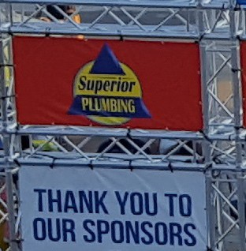

TITLE SPONSOR
- Full-page ad in North Georgia State Fair Premium Catalog (must have print ready ad by July 1, 2022)
- Twenty-five (25) Sponsor VIP Tent Tickets to use for the duration of the Fair
- Ten (10) VIP Sponsor Seats for Main Stage Concerts
- One hundred (100) VIP passes (unlimited Fair gate entry)
- Two-hundred and fifty (250) General Admission tickets to the Fair
- Twenty (20) staff parking passes
INVESTMENT: $100,000

For more information contact: Bill Watson 770.423.1330
09

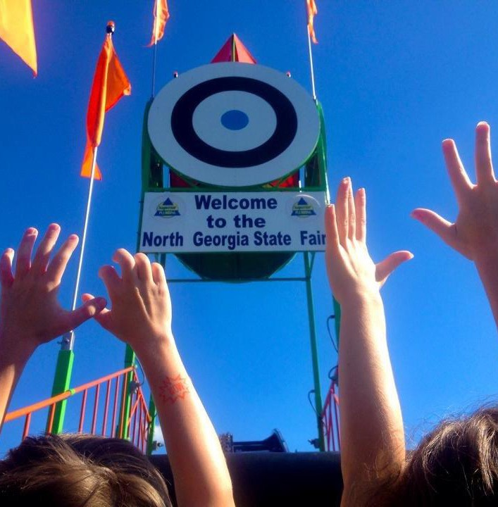
- Every time the North Georgia State Fair is mentioned, your company or brand is mentioned too! (“your company” North Georgia State Fair)
- Co-branded festival logo incorporating festival creative and your company logo
- Category exclusivity and first right of refusal by March 1, 2022 for 2022 Fair
- Prime placement of customizable on-site activation space (up to 40’ x 40’) or multiple spaces
- Opportunity to sample product to Fairgoers (samples size limited to 4oz)
- Opportunity to display up to five (5) company banners throughout fair grounds (sponsor to provide banners)
- Inclusion in all contracted print promotion
SOLD
- Inclusion in all contracted television promotion
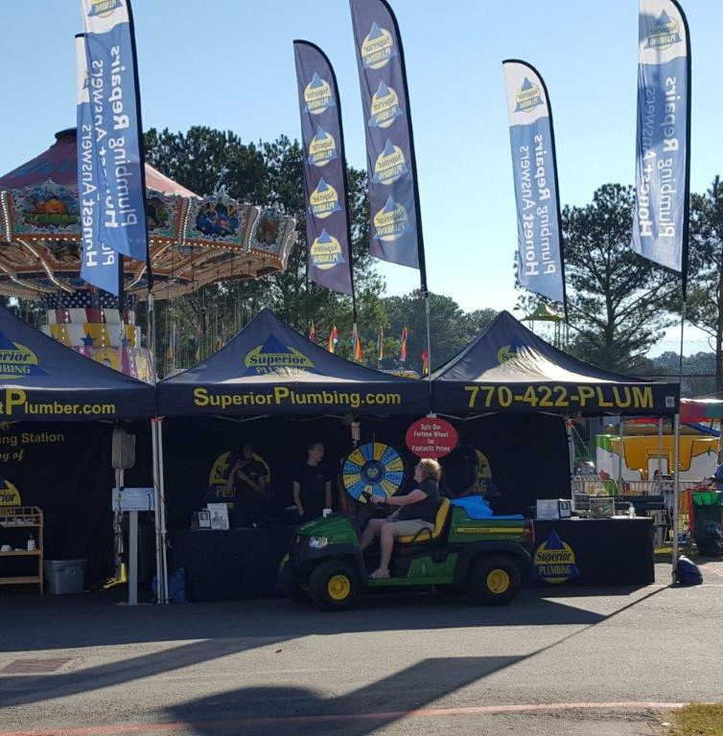
- Inclusion on all press releases as Title Sponsor
- Mention(s) in all contract radio promotion
- Inclusion in Main Stage announcements between entertainment acts
- Customizable inclusion on social media (up to ten (10) mentions prior to Fair and during Fair)
- Logo placement on Fair posters promotions (2,000 printed, distributed throughout Cobb County and Northwest Georgia)
- Logo placement on Fair banners a Title Sponsor
- Logo and hyperlink on Fair website www.northgeorgiastatefair.com
- Logo placement on Fair brochures (500,000 distributed – must have high res logo by July 1, 2022)

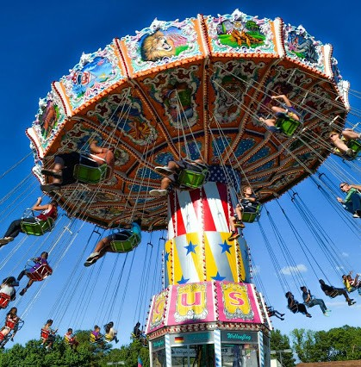

PRESENTING SPONSOR
- Fifteen (15) Sponsor VIP Tent Tickets to use for the duration of the Fair
- Eight (8) VIP Sponsor Seats for Main Stage Concerts
- Eighty (80) VIP passes (unlimited Fair gate entry)
- Two-hundred (200) General Admission tickets to the Fair
- Twenty (20) staff parking passes
INVESTMENT: $80,000
For more information contact: Bill Watson 770.423.1330
10

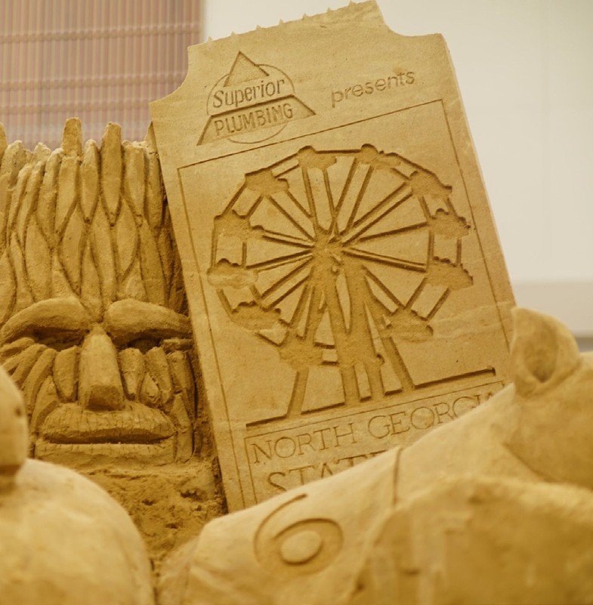
- Every time the North Georgia State Fair is mentioned, your company or brand is mentioned too! (North Georgia State Fair presented by “your company”)
- Co-branded festival logo incorporating festival creative and your company logo
- Category exclusivity and first right of refusal by March 1, 2022 for 2022 Fair
- Prime placement of customizable on-site activation space (up to 40’ x 40’) or multiple spaces
- Opportunity to sample product to Fairgoers (samples size limited to 4oz)
- Inclusion in all contracted print promotion
- Inclusion in all contracted television promotion
- Inclusion on all press releases as Presenting Sponsor
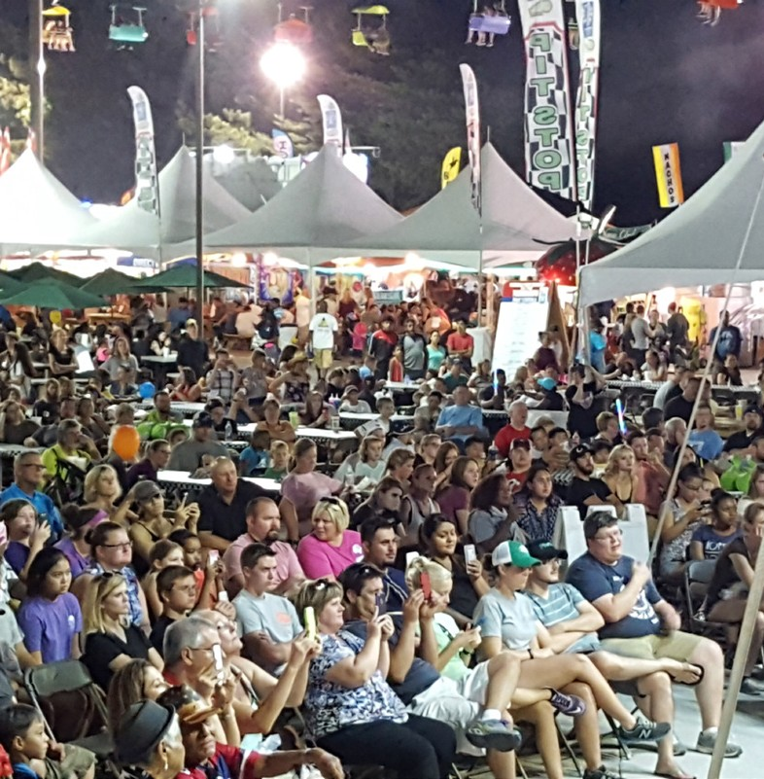
- Mention(s) in all contract radio promotion
- Inclusion in Main Stage announcements between entertainment acts
- Customizable inclusion on social media (up to six (6) mentions prior to Fair and during Fair)
- Logo placement on Fair posters promotions (2,000 printed, distributed throughout Cobb County and Northwest Georgia)
- Logo placement on Fair banners as Presenting Sponsor
- Logo and hyperlink on Fair website www.northgeorgiastatefair.com
- Logo placement on Fair brochures (500,000 distributed – must have high res logo by July 1, 2022)
- Full-page ad in North Georgia State Fair Premium Catalog (must have print ready ad by July 1, 2022)

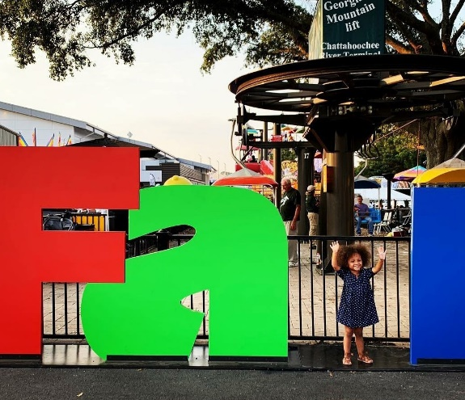

PREMIER SPONSOR
- One-hundred and fifty (150) General Admission tickets to the Fair
- Fifteen (15) staff parking passes
INVESTMENT: $50,000
For more information contact: Bill Watson 770.423.1330
11

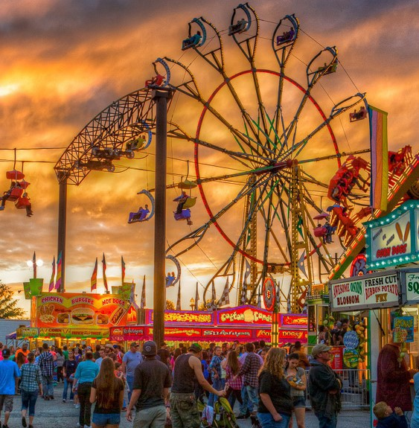
- Category exclusivity and first right of refusal by March 1, 2022 for 2022 Fair
- Naming rights and branding opportunity of one (1) event asset
- Prime placement of customizable on-site activation space (up to 40’ x 20’) or multiple spaces
- Opportunity to sample product to Fairgoers (samples size limited to 4oz)
- Inclusion in all contracted print promotion
- Inclusion in all contracted television promotion
- Inclusion on all press releases
- Mention(s) in all contract radio promotion
- Inclusion in Main Stage announcements between entertainment acts
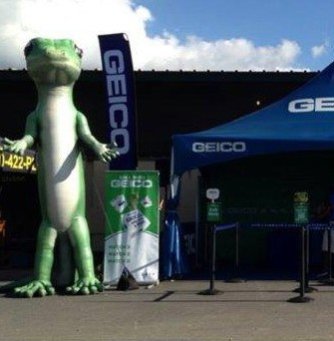
- Customizable inclusion on social media (up to five (5) mentions prior to Fair and during Fair)
- Logo placement on Fair posters promotions (2,000 printed, distributed throughout Cobb County and Northwest Georgia)
- Logo placement on Fair banners
- Logo and hyperlink on Fair website www.northgeorgiastatefair.com
- Logo placement on Fair brochures (500,000 distributed – must have high res logo by July 1, 2022)
- Full-page ad in North Georgia State Fair Premium Catalog (must have print ready ad by July 1, 2022)
- Fifteen (15) Sponsor VIP Tent Tickets to use for the duration of the Fair
- Six (6) VIP Sponsor Seats for Main Stage Concerts
- Sixty (60) VIP passes (unlimited Fair gate entry)

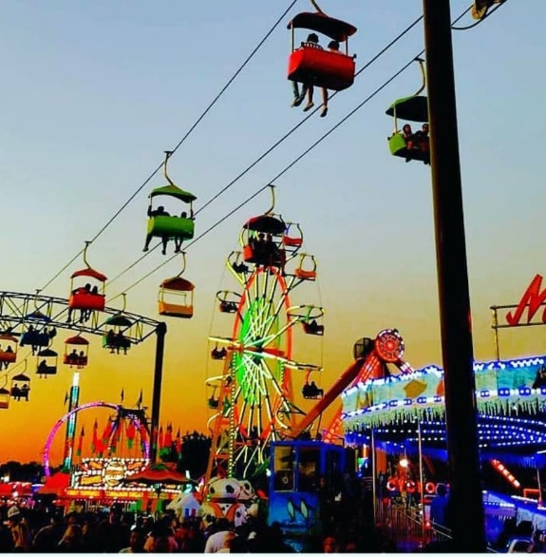

ELITE SPONSOR
- Twenty (20) staff parking passes
INVESTMENT: $30,000
For more information contact: Bill Watson 770.423.1330
12

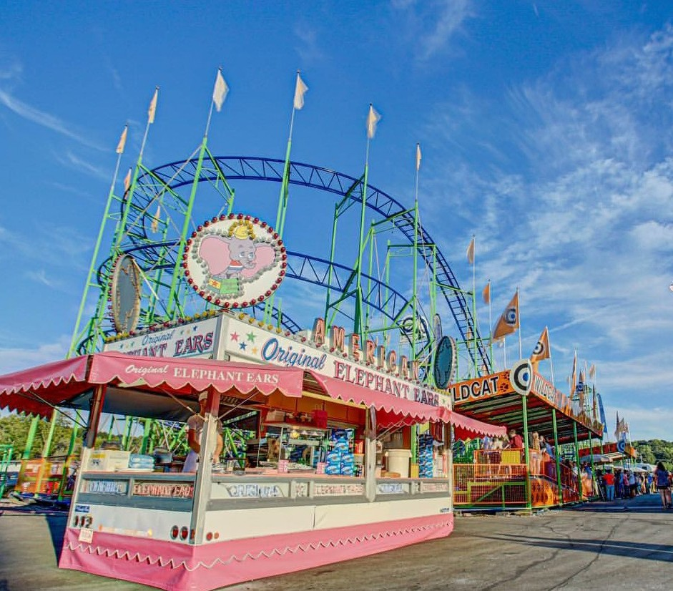
- Category exclusivity and first right of refusal by March 1, 2022 for 2022 Fair
- Naming rights and branding opportunity of one (1) event asset
- Prime placement of customizable on-site activation space (up to 20’ x 20’)
- Opportunity to sample product to Fairgoers (samples size limited to 4oz)
- Inclusion in select contracted print promotion
- Inclusion in select contracted television promotion
- Inclusion on all press releases
- Mention(s) in select contract radio promotion
- Inclusion in Local Stage announcements between entertainment acts
- Customizable inclusion on social media (up to three (3) mentions prior to Fair and during Fair)
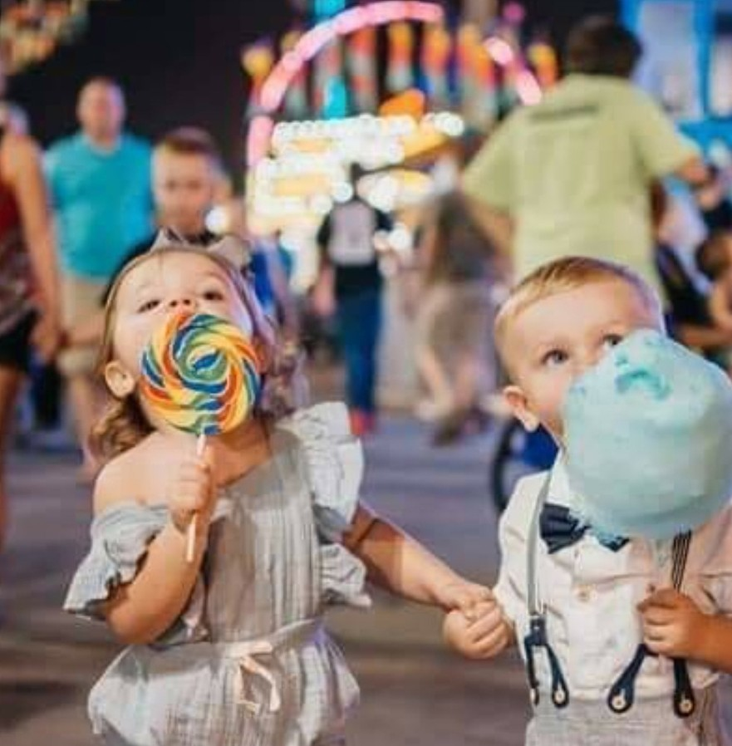
- Logo placement on Fair posters promotions (2,000 printed, distributed throughout Cobb County and Northwest Georgia)
- Logo placement on Fair banners
- Logo and hyperlink on Fair website www.northgeorgiastatefair.com
- Logo placement on Fair brochures (500,000 distributed – must have high res logo by July 1, 2022)
- Half-page ad in North Georgia State Fair Premium Catalog (must have print ready ad by July 1, 2022)
- Fifteen (15) Sponsor VIP Tent Tickets to use for the duration of the Fair
- Four (4) VIP Sponsor Seats for Main Stage Concerts
- Forty (40) VIP passes (unlimited Fair gate entry)
- One-hundred (100) General Admission tickets to the Fair

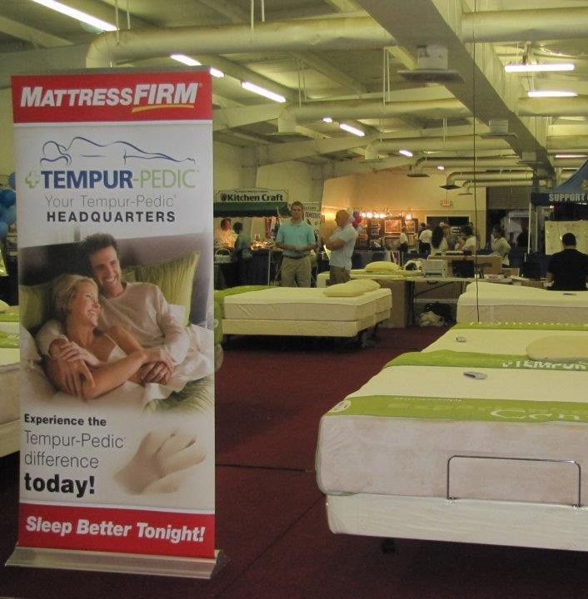

SUSTAINING SPONSOR
- Twenty (20) staff parking passes
INVESTMENT: $20,000
For more information contact: Bill Watson 770.423.1330
13

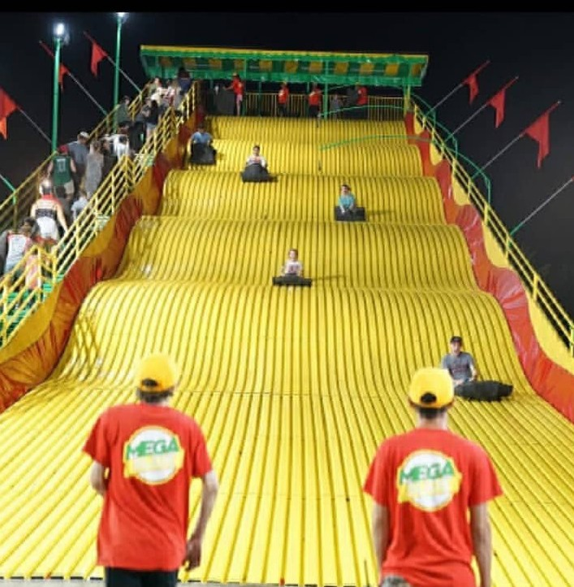
- Category exclusivity and first right of refusal by March 1, 2022 for 2022 Fair
- Naming rights and branding opportunity of one (1) event asset
- Prime placement of customizable on-site activation space (up to 20’ x 20’)
- Opportunity to sample product to Fairgoers (samples size limited to 4oz)
- Inclusion in select contracted print promotion
- Inclusion in select contracted television promotion
- Inclusion on all press releases
- Mention(s) in select contract radio promotion
- Inclusion in Local Stage announcements between entertainment acts
- Customizable inclusion on social media (up to two (2) mentions prior to Fair and during Fair)
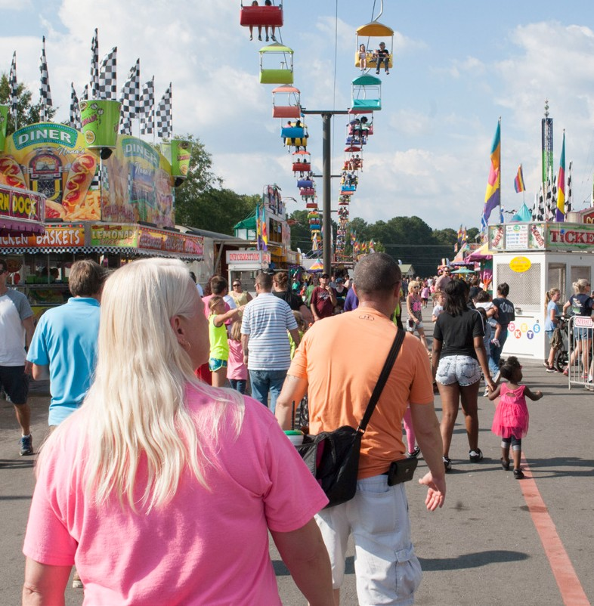
- Logo placement on Fair posters promotions (2,000 printed, distributed throughout Cobb County and Northwest Georgia)
- Logo placement on Fair banners
- Logo and hyperlink on Fair website www.northgeorgiastatefair.com
- Logo placement on Fair brochures (500,000 distributed – must have high res logo by July 1, 2022)
- Half-page ad in North Georgia State Fair Premium Catalog (must have print ready ad by July 1, 2022)
- Fifteen (15) Sponsor VIP Tent Tickets to use for the duration of the Fair
- Two (2) VIP Sponsor Seats for Main Stage Concerts
- Twenty (20) VIP passes (unlimited Fair gate entry)
- One-hundred (100) General Admission tickets to the Fair

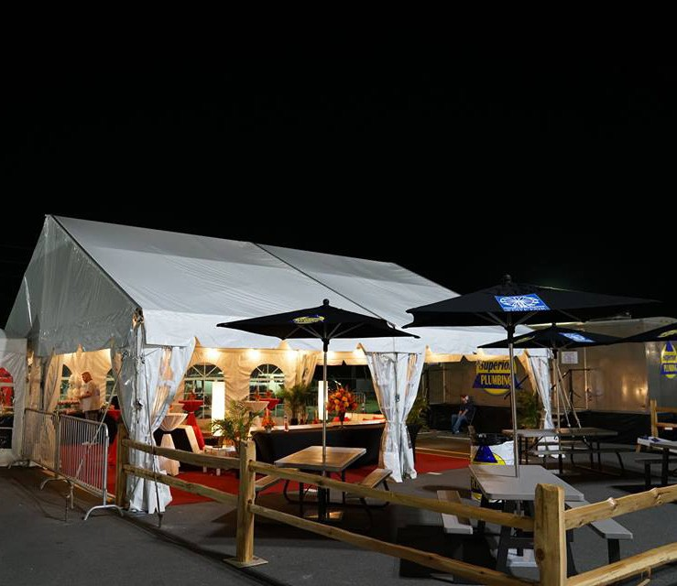

SUPPORTING SPONSOR
For more information contact: Bill Watson 770.423.1330
14

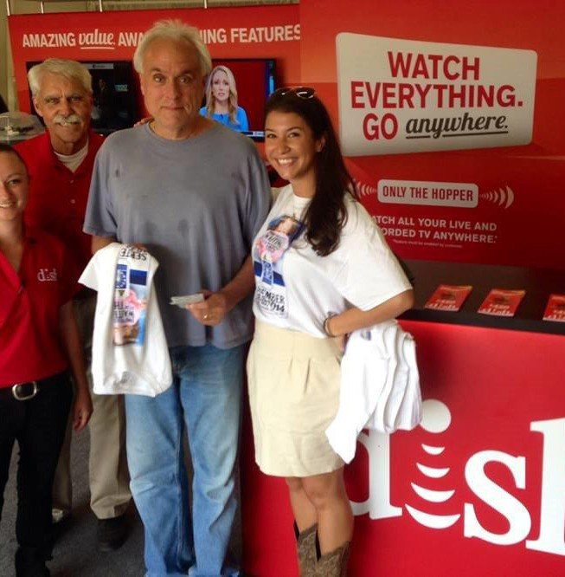
- Prime placement of customizable on-site activation space (up to 10’ x 30’)
- Opportunity to sample product to Fairgoers (samples size limited to 4oz)
- Inclusion in select contracted print promotion
- Inclusion on all press releases
- Customizable inclusion on social media (up to two (2) mentions prior to Fair and during Fair)
- Logo placement on Fair banners
- Logo and hyperlink on Fair website www.northgeorgiastatefair.com
- Logo placement on Fair brochures (500,000 distributed – must have high res logo by July 1, 2022)
- Quarter-page ad in North Georgia State Fair Premium Catalog (must have print ready ad by July 1, 2022)
- Eight (8) Sponsor VIP Tent Tickets to use for the duration of the Fair
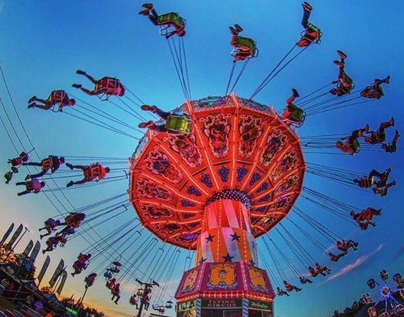
- Two (2) VIP Sponsor Seats for Main Stage Concerts
- Twenty (20) VIP passes (unlimited Fair gate entry)
- Fifty (50) General Admission tickets to the Fair
- Fifteen (15) staff parking passes

INVESTMENT: $15,000

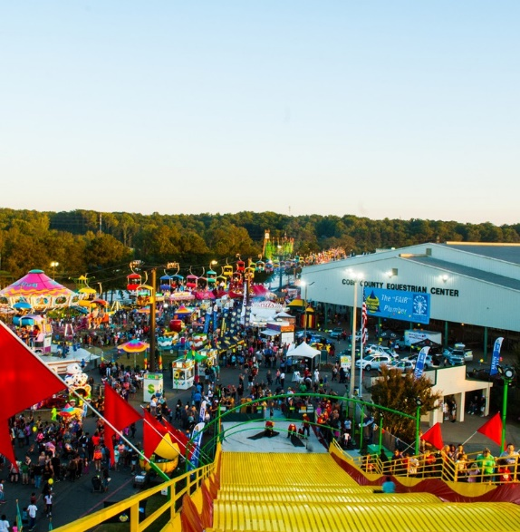

CONTRIBUTING SPONSOR
- Logo and hyperlink on Fair website www.northgeorgiastatefair.com
- Four (4) Sponsor VIP Tent Tickets to use for the duration of the Fair
- Five (5) VIP passes (unlimited Fair gate entry)
- Five (5) staff parking passes
INVESTMENT: $5,000
For more information contact: Bill Watson 770.423.1330
15

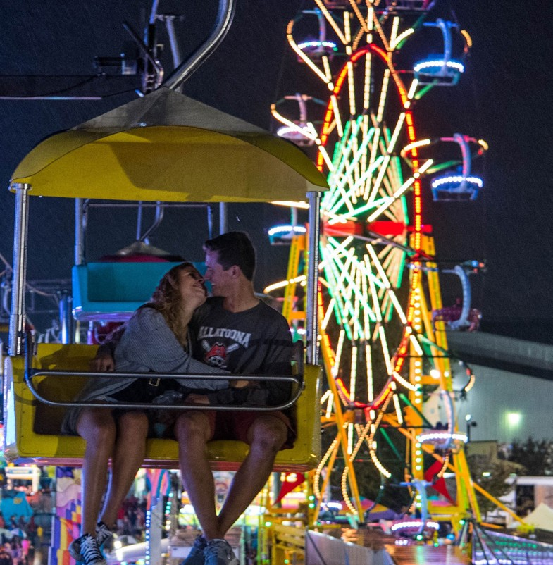
- Customizable on-site activation space (up to 10’ x 20’)
- Opportunity to sample product to Fairgoers (samples size limited to 4oz)
- Customizable inclusion on social media (up to two (2) mentions prior to Fair and during Fair)
- Logo placement on Fair banners
- Logo and hyperlink on Fair website www.northgeorgiastatefair.com
- Logo placement on Fair brochures (500,000 distributed – must have high res logo by July 1, 2022)
- Eight (8) Sponsor VIP Tent Tickets to use for the duration of the Fair
- Two (2) VIP Sponsor Seats for Main Stage Concerts
- Ten (10) VIP passes (unlimited Fair gate entry)
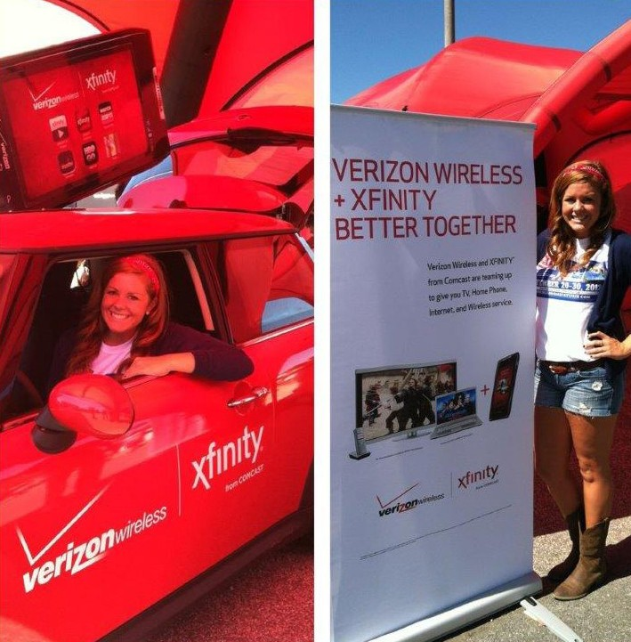
- Fifty (50) General Admission tickets to the Fair
- Ten (10) staff parking passes

INVESTMENT: $10,000

ON-SITE DISPLAY SPONSOR
- On-site activation space (up to 10’ x 10’)

